|  |
| --- |
|  |
| 新概念 3 册 |
| Lesson24 A skeleton in the cupboard |

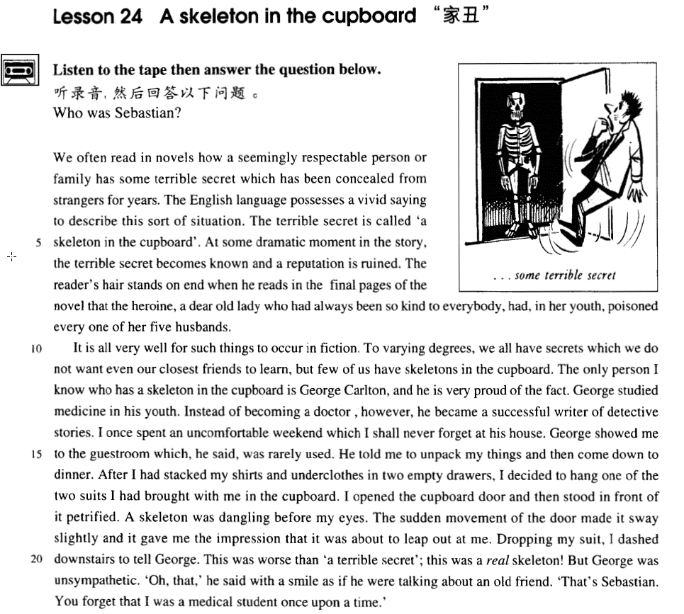

课文

We often read in novels how a seemingly respectable person or family has some terrible secret which has been concealed from strangers for years.

在小说中，我们经常读到一个表面上受人尊重的人物或家庭，却有着某种多年不为人所知的骇人听闻的秘密。

The English language possesses a vivid saying to describe this sort of situation.

英语中有一个生动的说法来形容这种情况。

The terrible secret is called 'a skeleton in the cupboard'.

惊人的秘密称作“柜中骷髅”。

At some dramatic moment in the story, the terrible secret becomes known and a reputation is ruined.

在小说的某个戏剧性时刻，可怕的秘密泄漏出来，接着便是某人的声誉扫地。

The reader's hair stands on end when he reads in the final pages of the novel that the heroine, a dear old lady who had always been so kind to everybody, had, in her youth, poisoned every one of her five husbands.

当读者到小说最后几页了解到书中女主人公，那位一向待大家很好的可爱的老妇人年轻时一连毒死了她的5个丈夫时，不禁会毛骨悚然。

It is all very well for such things to occur in fiction.

这种事发生在小说中是无可非议的。

To varying degrees, we all have secrets which we do not want even our closest friends to learn, but few of us have skeletons in the cupboard.

尽管我们人人都有各种大小秘密。连最亲密的朋友都不愿让他们知道，但我们当中极少有人有柜中骷髅。

The only person I know who has a skeleton in the cupboard is George Carlton, and he is very proud of the fact.

我所认识的唯一的在柜中藏骷嵝的人便是乔治.卡尔顿，他甚至引以为自豪。

George studied medicine in his youth. Instead of becoming a doctor, however, he became a successful writer of detective stories.

乔治年轻时学过医，然而，他后来没当上医生，却成了一位成功的侦探小说作家。

I once spent an uncomfortable weekend which I shall never forget at his house.

有一次，我在他家里度周末，过得很不愉快。这事我永远不会忘记。

George showed me to the guestroom which, he said, was rarely used.

乔治把我领进客房，说这间很少使用。

He told me to unpack my things and then come down to dinner.

他让我打开行装后下楼吃饭。

After I had stacked my shirts and underclothes in two empty drawers, I decided to hang one of the two suits I had brought with me in the cupboard.

我将衬衫、内衣放进两个空抽屉里，然后我想把随身带来的两套西服中的一套挂到大衣柜里去。

I opened the cupboard door and then stood in front of it petrified.

我打开柜门，站在柜门前一下惊呆了。

A skeleton was dangling before my eyes.

一具骷髅悬挂在眼前，

The sudden movement of the door made it sway slightly and it gave me the impression that it was about to leap out at me.

由于柜门突然打开，它也随之轻微摇晃起来，让我觉得它好像马上要跳出柜门朝我扑过来似的。

Dropping my suit, I dashed downstairs to tell George.

我扔下西服冲下楼去告诉乔治。

This was worse than 'a terrible secret'; this was a real skeleton!

这是比“骇人听闻的秘密”更加惊人的东西，这是一具真正的骷髅啊！

But George was unsympathetic. 'Oh, that,' he said with a smile as if he were talking about an old friend.

但乔治却无动于衷。“噢，是它呀！他笑着说道，俨然在谈论一位老朋友。

That's Sebastian. You forget that I was a medical student once upon a time.'

“那是塞巴斯蒂安。你忘了我以前是学医的了。”

词汇讲解

* **seemingly ['si:mɪŋli] adv.** 看似，表面上(暗示，其实不是这样的)
* Running a mile under 4 minutes was a **seemingly** impossible task.

**on the surface** 表面上

* Mike was very pleasant **on the surface**, but he had a nasty temper.

**seem / appear to do** 表面上

* Running a mile under 4 minutes **seemed / appeared to be** an impossible task.
* Mike **seemed** / **appeared to be** very pleasant, but he had a nasty temper.

**It seem / appear that …** 表面上

* It **seemed** / **appeared** **that** running a mile under 4 minutes was an impossible task.
* It **seemed** / **appeared** **that** Mike was very pleasant, but he had a nasty temper.

**seeming / superficial** adj 表面上

* In spite of his **seeming** / **superficial** friendship, he gave me no help.
* **respectable** [rɪ'spektəbl] adj. 体面的，正派的
* a **respectable** citizen
* a **respectable** family
* He is a bit **too respectable** (略带贬义，太正派，太古板) for my taste.

**respected** ***adj.*** 受尊敬的，有名气的

* a highly **respected** surgeon

**respectful** ***adj.*** 恭敬的；有礼貌的

* You should be more **respectful** **of** other people’s points of view.

**respective** ***adj.*** 分别的，各自的

* After the party we all went back to our **respective** homes.

**介词**，相当于“about”:

**respecting *prep.*** 关于；就…而言；鉴于

**concerning *prep.*** 关于；就…而言

**regarding *prep.*** 关于，至于

* **造句**：在这篇有关科学家的文章中，作者特别尊重那些不但是体面正派的公民，而且在各自的领域中都深受敬仰的专家。
* In the article **respecting** scientists, the writer is particularly **respectful** of those who are not only **respectable** citizens, but **respected** experts in their **respective** fields.
* **conceal** [kən'si:l] **v. 隐瞒，隐藏**

**conceal … from …** 向…隐瞒

**hide … from …**

**reveal … to …** 揭示…给…

**disclose … to …**

**expose … to …**

* **fiction ['fɪkʃn]** n. 小说

**可数** **不可数**

novel fiction

poem poetry

myth mythology

scene scenery

jewel jewellery (jewelry)

machine machinery

leaf foliage

table / chair … furniture

pen / pencil … stationery

trunk / suitcase … luggage / baggage

* **unpack** [ʌn'pæk]v. （从箱中）取出

反义

pack unpack

load unload

lock unlock

fasten unfasten

screw unscrew

* **petrify ['petrɪfaɪ]** v. 使……惊呆，使石化

**horrify** ***vt.*** 使恐惧；惊骇；使极度厌恶

**terrify** ***vt.*** 恐吓；使恐怖；使害怕

**frighten *vt.*** 使惊吓；吓唬… ***vi.*** 害怕，惊恐

**scare *vt.*** 惊吓；把…吓跑 ***vi.*** 受惊

**be frightened / scared / afraid of …** 害怕…

* Many girls **are** **frightened** / **scared** / **afraid** **of** cockroaches.
* **dangle** ['dæŋgl] v. 悬挂（并摆动）
* A hanger **dangled** on the rope.

**suspend** ***vt.*** 延缓，推迟；使暂停；使悬浮***vi.*** 悬浮；禁赛

**hang** ***v.*** 悬挂，垂下

**sway** ***v.*** 影响；摇摆

**swing** ***v.*** 摇摆

* **unsympathetic** [ʌnsɪmpə'θetɪk] adj. 不同情的，无动于衷的

**unsympathetic** ***adj.*** 不表同情的；不同情的

**sympathetic** ***adj.*** 同情的；交感神经的；共鸣的；赞同的；和谐的；合意的

**pathetic** ***adj.*** 可怜的，悲哀的；感伤的；乏味的

**apathetic** ***adj.*** 冷漠的；无动于衷的，缺乏兴趣的

**sympathize** ***vi.*** 同情，怜悯；支持

**sympathize** **with …** 同情某人

**sympathy *n.*** 同情；慰问；赞同

**show sympathy**  展示同情

**win sympathy** 赢得同情

**out of sympathy** 出于同情

* **Out of sympathy**, I gave the beggar some change.

课文讲解

# （题目）

# A skeleton in the cupboard

习语：家丑

* A skeleton in the cupboard【英】/ closet【美】习语：家丑
* a family skeleton 习语：家丑
* wash one’s dirty linen 习语：家丑外扬
* air one’s dirty laundry 习语：家丑外扬

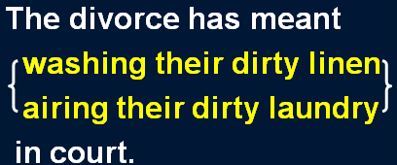

# （第一段）

# We often read in novels how a seemingly respectable person or family has some terrible secret which has been concealed from strangers for years.

We often read in novels(地点状语) how a seemingly respectable person or family has some terrible secret（宾语） *which has been concealed from strangers for years*. （定语从句）

知识点（1）

**some 用法：**

some+不可数名词：一些；some water 一些水

some+可数名词复数：一些；some people 一些人

some+可数名词单数：某个；some person 某一个人

some+数量词：大约；some one hundred people 大约100人

* some terrible secret （某个秘密）
* Some person（某个人） at the door is asking to see you.

知识点（2）

**be concealed from…** 向某人隐瞒

… which has been **hidden from** strangers for years.

* **造句**：我们常常在报纸上会读到一个表面上很体面的名人 (personality) 是如何因为偷税漏税 (tax evasion) 而被起诉的 (be charged with …)，而这种行为他们对公众 (the public) 隐瞒了很多年。
* We often read in newspapers how a seemingly respectable personality was charged with tax evasion which had been concealed from the public for years.

# The English language possesses a vivid saying to describe this sort of situation.

**saying**: proverb* / adage* 谚语；格言

* The Chinese language possesses a vivid **saying** ‘God favors the diligent*’（天道酬勤）.

# The terrible secret is called 'a skeleton in the cupboard'.

# At some dramatic moment in the story, the terrible secret becomes known and a reputation is ruined.

dramatic moment 戏剧性的时刻

At the **climax**\* （高潮）of the story, …

* **造句**：这个道貌岸然的官员 (official) 贪污 (embezzle) 了巨额公款 (enormous government funds)。现在这个秘密已经公开了，他也名声扫地。
* The seemingly respectable official embezzled* enormous government funds. Now the secret becomes known and his reputation is ruined.

# The reader's hair stands on end when he reads in the final pages of the novel that the heroine, a dear old lady who had always been so kind to everybody, had, in her youth, poisoned every one of her five husbands.

The reader's hair stands on end *when he reads in the final pages of the novel （地点状语前置）that the heroine, a dear old lady（同位语） who had always been so kind to everybody（定语从句）, had, in her youth（插入语）, poisoned every one of her five husbands*.

知识点（一）

**make one’s hair stand on end** 使某人毛发树立

* Wait until I tell you about the murder—it'll **make your hair stand on end**.

**make one’s blood run cold** 吓得某人手脚冰凉

**frighten / scare the life out of sb.** 突如其来的事吓某人一跳

**frighten / scare the hell out of sb.**

* **美剧**
* Lynette? Honey?
* Are you home? Three months.
* God, you scared the hell out of me!

知识点（二）

**in one’s youth** 在某人年轻的时候

**in one’s childhood**

**in one’s early years** 小的时候

**in one’s adolescence** 青春期

**in one’s middle age** 中年

**in one’s old age** 老年

* 造句：当我在电视剧 (TV drama) 的最后一集 (the final episode) 看到主人公，那个对每个人都很友善的体面的 (respectable) 律师，原来竟是个 (turn out to be) 残忍的谋杀犯时 (a savage murderer)，被吓得毛骨悚然。
* My hair stood on end when I watched in the final episode* of the TV drama that the hero, a respectable lawyer who had been so kind to everybody, turned out to be a savage murderer.

# （第二段）

# It is all very well for such things to occur in fiction.

* It is all very well for such things to occur in fiction, **but in real life it is barely credible** （后半句补充）.

**It is all very well for … to …, but … it is barely …** 做某事是无可厚非的，但是这个情况下就…

* **造句**：你在家里穿睡衣 (pajamas) 是无可厚非的，但是在公共场合就不太体面了。
* **It is all very well for** you **to** wear pajamas* in your own home, **but** in public **it is barely** respectable.

# To varying degrees, we all have secrets which we do not want even our closest friends to learn, but few of us have skeletons in the cupboard.

*To varying degrees（状语）*, we all have secrets which we do not want even our closest friends to learn, but few of us have skeletons in the cupboard.

知识点（一）

**to varying degrees** 在不同的程度上

* Racism still exists **to varying degrees**.
* The water of rivers, lakes and reservoirs* in China was universally polluted **to varying degrees**.

知识点（二）

**closest friend** 挚友，密友

**intimate**\* **friend** 挚友，亲友

**bosom**\* **friend** 知心朋友

**fair-weather friend** 酒肉朋友

**pen** **pal** / **friend** 笔友

**internet** **pal** / **friend** 网友

# The only person I know who has a skeleton in the cupboard is George Carlton, and he is very proud of the fact.

The only person I know （定语从句，修饰only person）who has a skeleton in the cupboard is George Carlton（定语从句，修饰‘The only person I know’整个名词短语）, and he is very proud of the fact.

知识点（一）

**语法：**不在同一层次上的双重定语从句

第一个定语从句修饰前面的名词或短语，第二个定语从句修饰“名词或短语+第一个定语从句”两个定语从句之间没有并列连词连接。第一个定语从句的关系词(一般是关系代词作宾语)可省略。

* You’re the only person *I’ve ever met* **who** could do it.
* He’s the best man *I can find* **who** can mend it within an hour.

知识点（二）

表达“**对…很自豪**”：

**be proud of …**

**take pride in …**

**pride oneself on …**

* Much as we may **pride ourselves on** our good taste, we are no longer free to choose the things we want, for advertising exerts a subtle influence on us.

# George studied medicine in his youth. Instead of becoming a doctor, however, he became a successful writer of detective stories.

**instead of doing …, however, …** 本该做…，然而，…

* **Instead of becoming** a doctor, **however**, Lu Xun became China’s foremost modern writer of satirical* essays.

# I once spent an uncomfortable weekend which I shall never forget at his house.

uncomfortable weekend

**语法**：transferred epithet **移就**，把本该修饰人的词，用它来修饰事物。

* a sad letter
* a lonely night
* 平林漠漠烟如织，寒山一带**伤心碧** （中文**移就**表达）
* 自春来、**惨绿愁红**，芳心是事可可。（中文**移就**表达）

# George showed me to the guestroom which, he said, was rarely used.

**show** = lead 领某人去某地

* Aleko denied taking it and **led** Dimitri into his back yard.

# He told me to unpack my things and then come down to dinner.

unpack 从箱子里取出东西

unpack my things / belongings

unpack my suitcase

# After I had stacked my shirts and underclothes in two empty drawers, I decided to hang one of the two suits I had brought with me in the cupboard.

# I opened the cupboard door and then stood in front of it petrified.

petrified 过去分词做形容词

**语法：**形容词作主语补足语，补充说明动作发生时，主语的状态。

* She came home *sick*.
* Only the good die *young*.
* Inevitably you arrive at your destination ***almost exhausted***.
* However you decide to spend your time, one thing is certain: you will arrive at your destination ***fresh and uncrumpled*.**

# A skeleton was dangling before my eyes.

# The sudden movement of the door made it sway slightly and it gave me the impression that it was about to leap out at me.

知识点（一）

**give sb. the impression that …** 使某人觉得

**have / get the impression that …** 使某人觉得

**be under the impression that ...** 误以为

* 课文写法替换
* … and I **had / got the impression that** it was about to leap out …
* … and I **was** **under the impression that** it was about to leap out …
* Though the crew **were** at first **under the impression that** the lost ship had been found, the contents of the chest proved them wrong.

知识点（一）

**be about to do …**正要做某事

**be on the point of doing …** 正要做某事的时刻

* 课文写法替换：
* It **was on the point of leaping** out at me.
* **课后题：**
* 12. - gave me the impression that it ___A___ **leaping** out at me. (1.19)

(a) was on the point of (b) was concerned with (c) was thinking of (d) was almost

知识点（三）

词汇辨析：跳

**leap** 用力的往远跳

**jump** 没有特殊含义

**bounce** 弹跳

* That’s one small step for a man, one giant **leap** for mankind. — Neil Armstrong

**by leaps and bounds**: very quickly

* 听力真题：

A．He's growing very quickly.

B．He's the tallest of three boys.

C．He can jump high.

D．He has to leave today at there.

* M: Your little nephew is growing **by leaps and bounds**.
* W: Yes. He must be at least three feet tall already.
* Q: What do the speakers say about the woman’s nephew?
* Answer: (A) He's growing very quickly.

# Dropping my suit, I dashed downstairs to tell George.

**dash** 由静止突然启动

**rush** 匆忙的走

# This was worse than 'a terrible secret'; this was a *real skeleton*!

*斜体字醒目，重读

# But George was unsympathetic. 'Oh, that,' he said with a smile as if he were talking about an old friend.

* But George didn’t **sympathize** with me.
* But George **had / showed no sympathy** for(感情词用for) me.
* Don’t act as if you **were** the only pebble on the beach. 【谚】不要自视太高

# That's Sebastian. You forget that I was a medical student once upon a time.'

medical student

**medical staff** 全体医护人员

**medical ethics** 医德

**upon** 此处不能换成on，

**once upon a time** 很久以前